AWS CloudFront  
   
  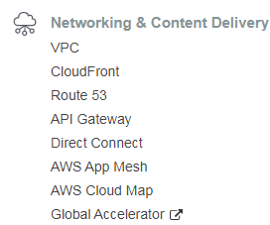  
  
What is it ? : Amazons content delivery network (cloud front distribution.).  
  
What is a CDN : It is a network of distributed servers that deliver web content to a user ‘Based’ on the **G**eographical location of the user + **O**rigin of the web page + **A**nd a content delivery server.  
   
It is good if your users are geographically located.  
   
 Under a normal scenario, if you web server is in a particular location, and the number of network hops for a request (& response too) originated geographically far from your server will be more.  
 The network latency is going to be different for people located in geographically different places. For those users who are further away they will have worst experience and more latency.  
  
Any similarities with Transfer Acceleration in S3 ?  
We can use Cloud front to accelerate the transfer of files into S3, which is called S3 Transfer Acceleration.  
TA enables fast easy and secure transfer of your files, over long distances between your end users and the S3 bucket.  
This takes advantage of cloud fronts globally distributed edge locations.  
  
Cloud front is focused on content delivery – allowing fast reads and downloads.  
Transfer Acceleration : Enabling faster uploads into S3.  
  
Instead of a user accessing the files in the webserver between their location AND webserver, we introduce a concept called edge locations.

Edge locations : They are just a collection of servers in geographically dispersed data centers.   
  
 These edge locations are used by cloud front to keep a cache of copies of your objects.  
  
 This means that instead of requesting data from the server located in London, user can   
 access that content from the edge location.  
  
 Instead of making a request to the London server, the request is made to the edge  
 location which is closer geographically.  
  
 Once the request is made the edge location forwards the request to the main server, It   
 then downloads the files and caches them locally.  
  
 Objects are cached and as a result : it improves the application performance and app  
 will have low latency.  
  
 Objects are cached till a TTL - time to live period. Post which the objects are cleared   
 from cache.  
  
 Manually clearing the cache – you will be charged in this case.  
 There are more Edge locations than aws availability zones and aws Regions.  
  
Cloud front is optimized to work with S3,EC2,Route53,ELB, and your origin server.  
  
Cloud front distribution types.  
Web Distribution : Used for Web sites. The origin can be an S3 bucket or Http server.  
RTMP Distribution(Not Available after December 2020) : We can stream media files using the adobe media server + adobe RTMP(real time messaging protocol).

**Cloud Front LAB.**  
Create a S3 Bucket in a far off region and upload a 5mb file + notice how it loads via the s3 url.  
  
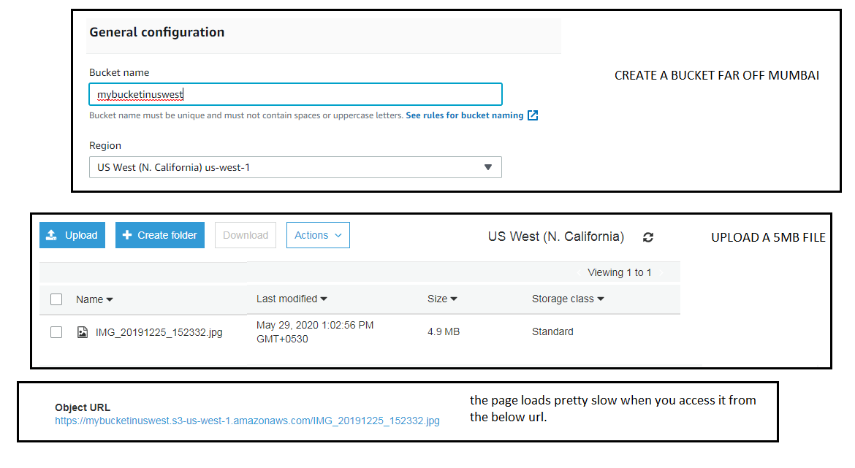  
  
1/1 : Create a distribution.  
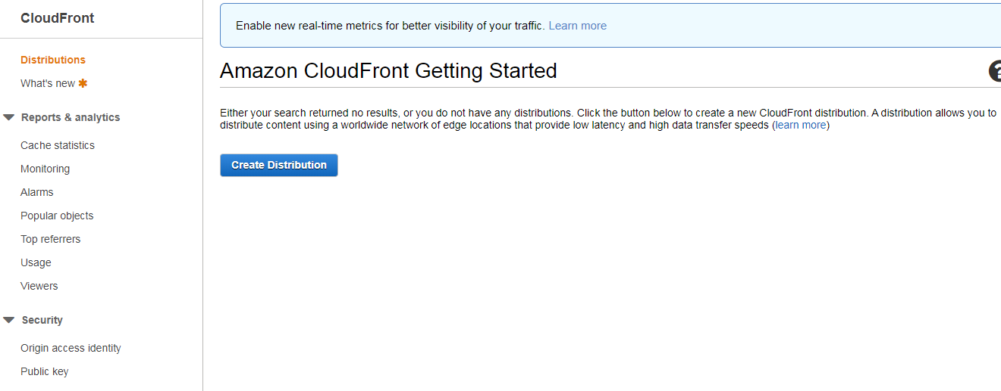  
  
1/2 : Select Web distribution.  
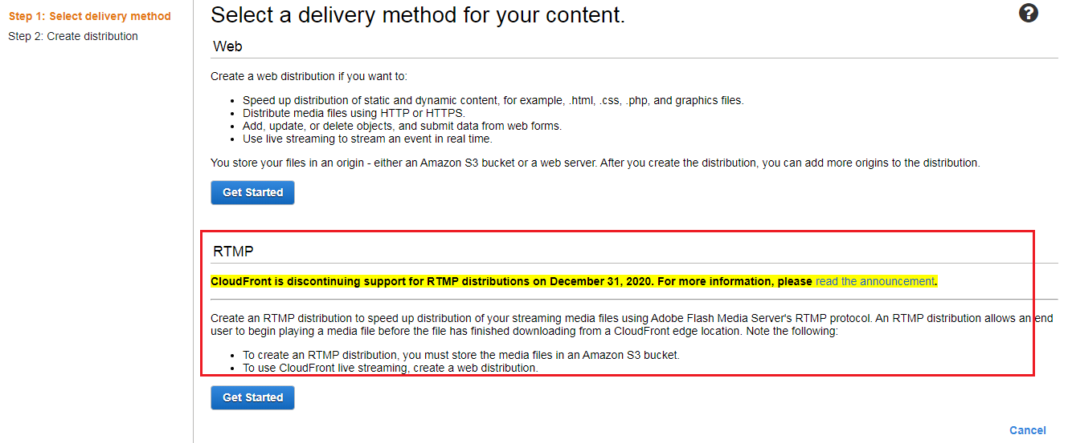  
  
1/3.1 : Origin settings.  
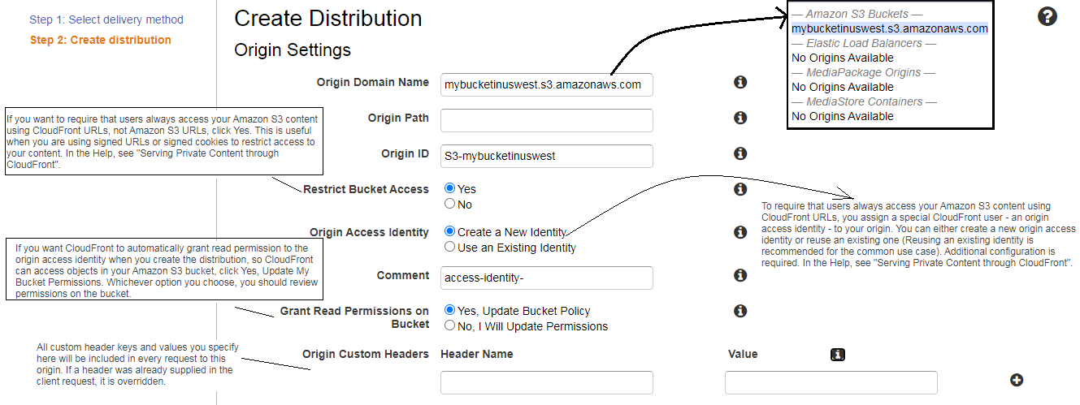

1/3.2 : Cache Behavior settings.  
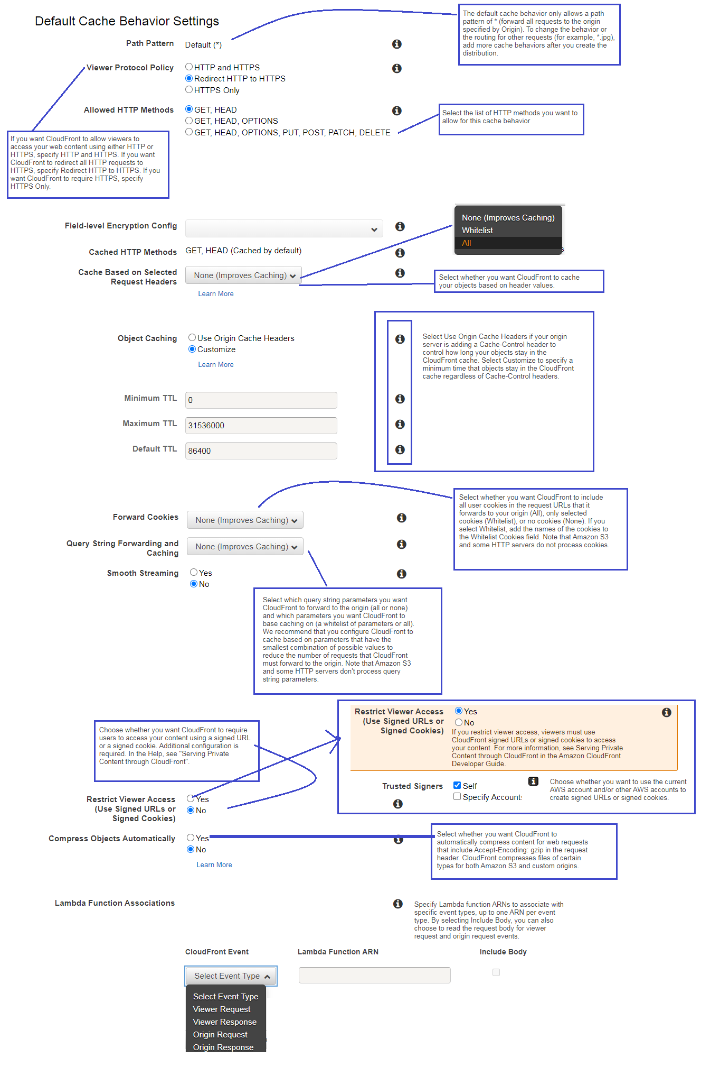

1/3.3 Distribution settings.  
  
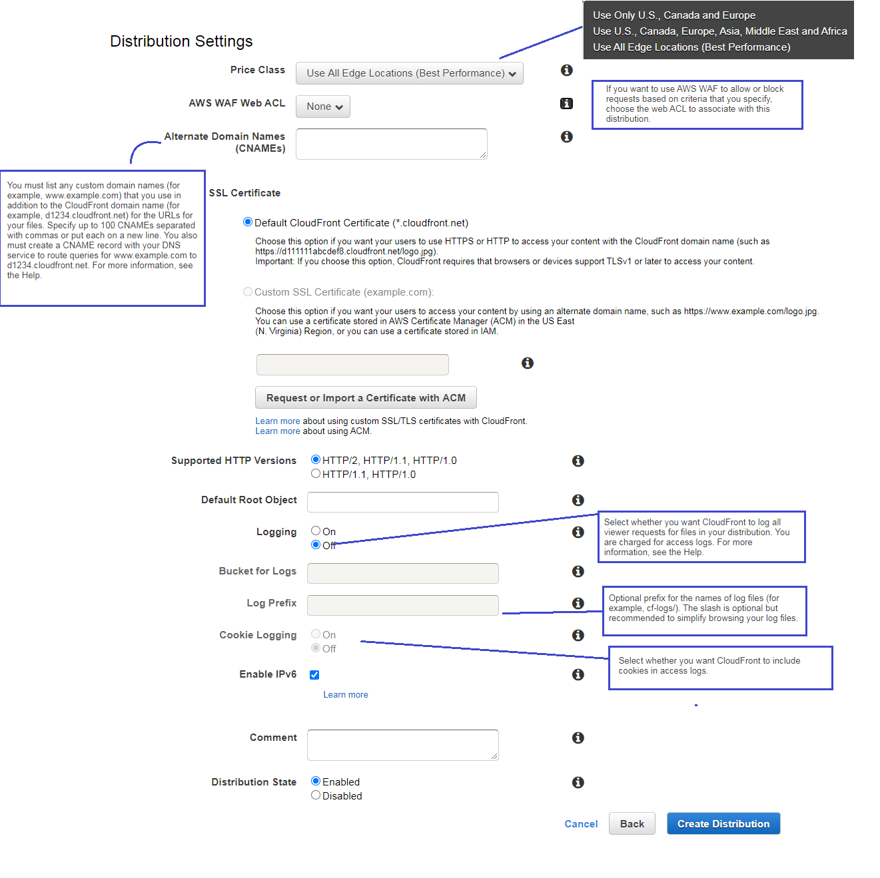  
  
List all the cloud front distributions.  
  
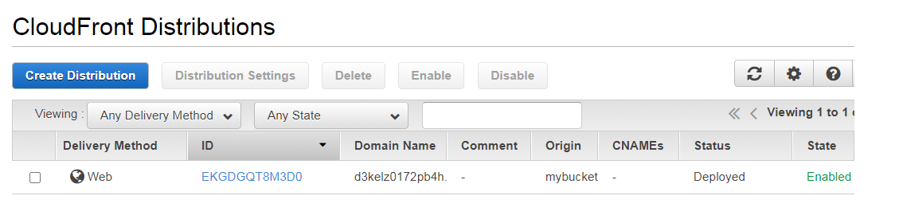  
  
All the tab of a distribution look as below.  
Tab/1 : General Tab.  
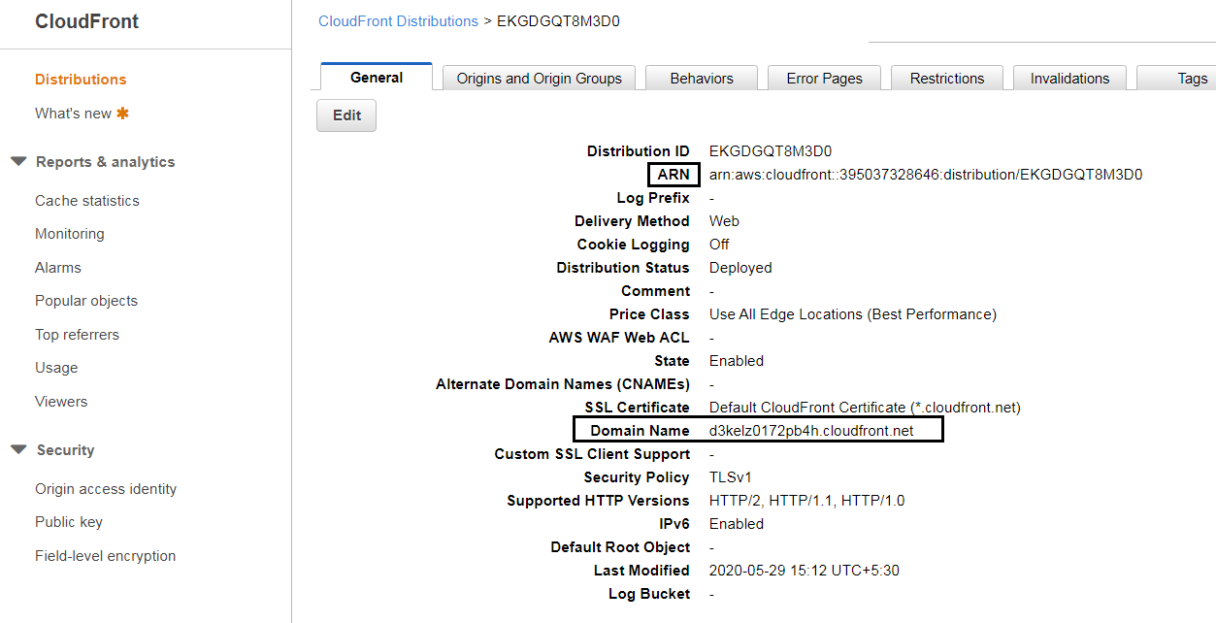  
Tab/2 : Origins tab.  
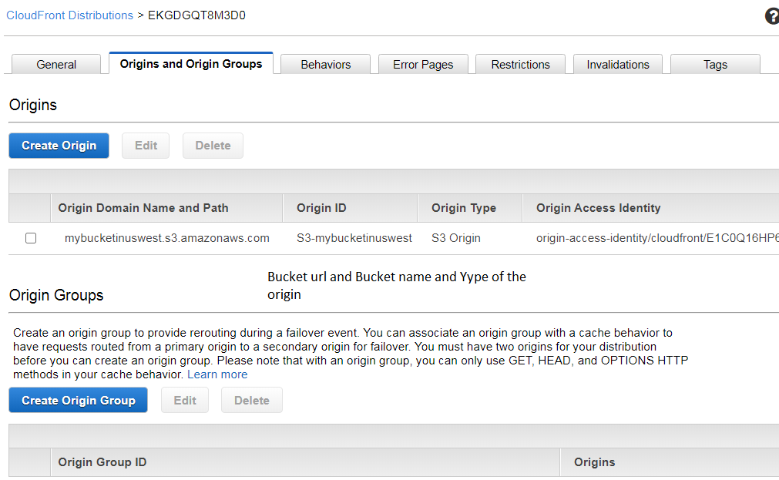

Tab/3 : Behaviors.

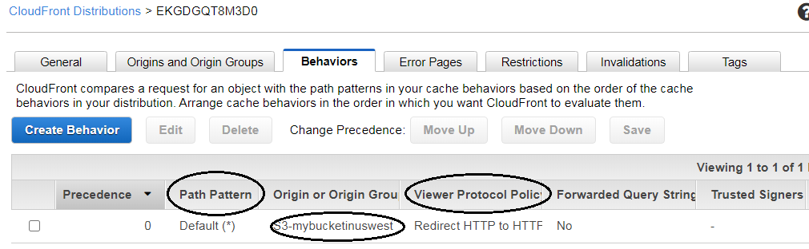

Tab/4 : Error Pages.  
  
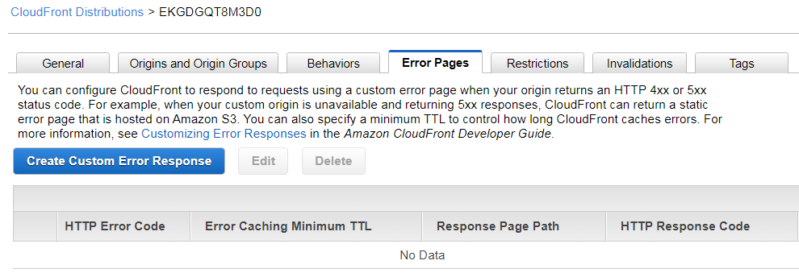  
  
Tab/5 : Restrictions.  
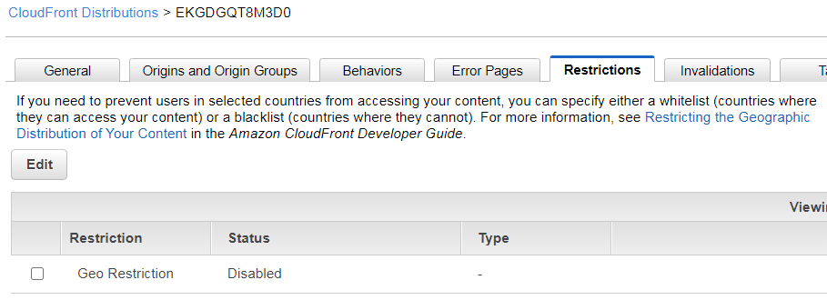  
Tab/6 : Invalidations.  
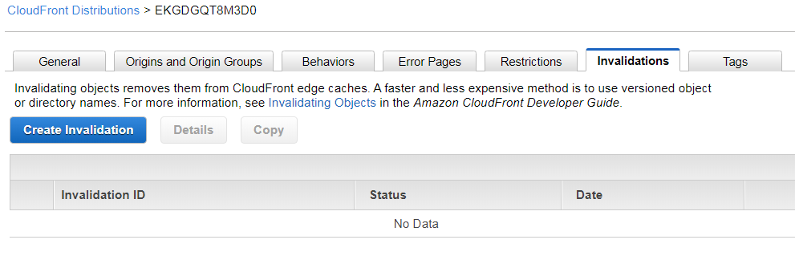  
  
Tab/7 : Tags .  
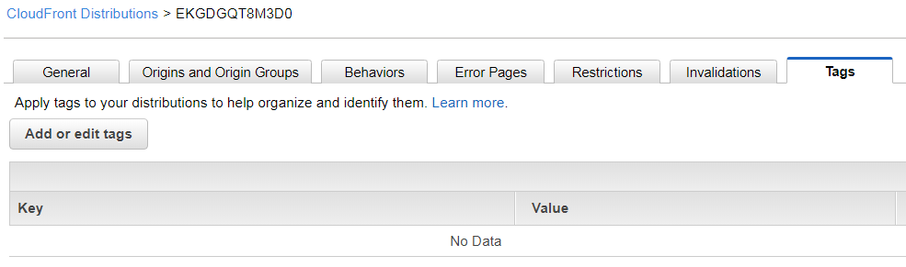  
  
How to do you check if the s3 is accessible faster.  
1. Access the bucket image using the below url before configuring cloud front distribution.  
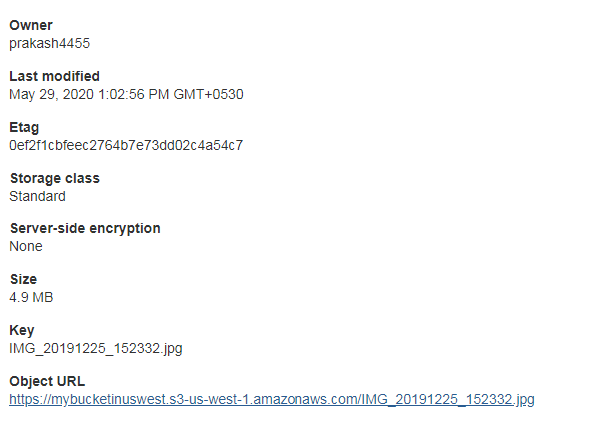

2.Get the domain name of the cloud fron distribution and add it below here.  
The first time you access the file the object will have to cached in the edge location.  
And the second time you access from **another** browser it will be faster than earlier.  
 